Lakiel Wade

CIS 408 Internet programming

Project 3

Problem 1

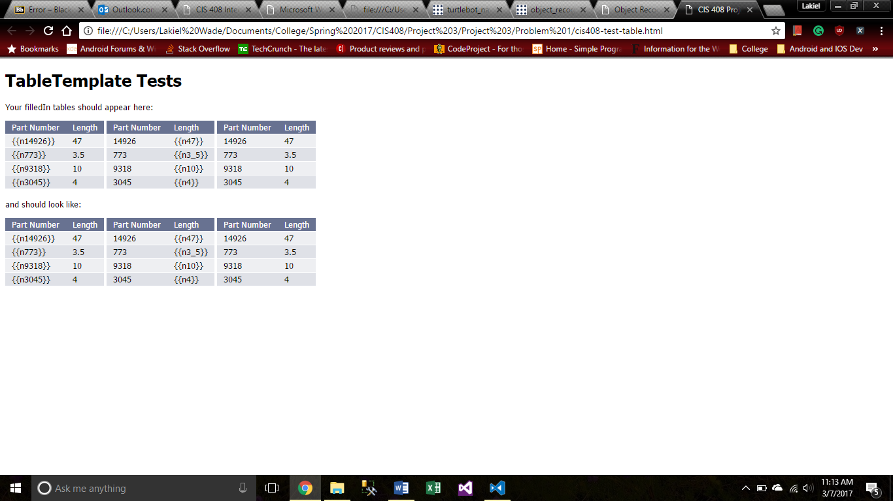

TableTemplate.js

class TableTemplate {

    static fillIn(id, dict, coulmnName) {

        var reg = new RegExp(/{{(\w+)}}/i);

        var coulmnNames = [];

        var row = document.getElementById(id).rows;

        for (var x = 0; x < row.length; x++) {

            var cells = row[x].cells;

            if (x === 0) {

                for (var y = 0; y < cells.length; y++) {

                    var tempBool = reg.test(cells[y].innerHTML);

                    if (tempBool) {

                        var val = reg.exec(cells[y].innerHTML);

                        var swap = dict[val[1]];

                        cells[y].innerHTML = swap;

                        coulmnNames.push(swap);

                    }

                }

            }

            else {

                if (coulmnName == null) {

                    for (var y = 0; y < cells.length; y++) {

                        var tempBool = reg.test(cells[y].innerHTML);

                        if (tempBool) {

                            var val = reg.exec(cells[y].innerHTML);

                            var swap = dict[val[1]];

                            cells[y].innerHTML = swap;

                        }

                    }

                }

                else {

                    var updateCoulmn = coulmnNames.indexOf(coulmnName);

                    var tempBool = reg.test(cells[updateCoulmn].innerHTML);

                    if (tempBool) {

                        var val = reg.exec(cells[updateCoulmn].innerHTML);

                        var swap = dict[val[1]];

                        cells[updateCoulmn].innerHTML = swap;

                    }

                }

            }

        }

    }

}

Problem 3

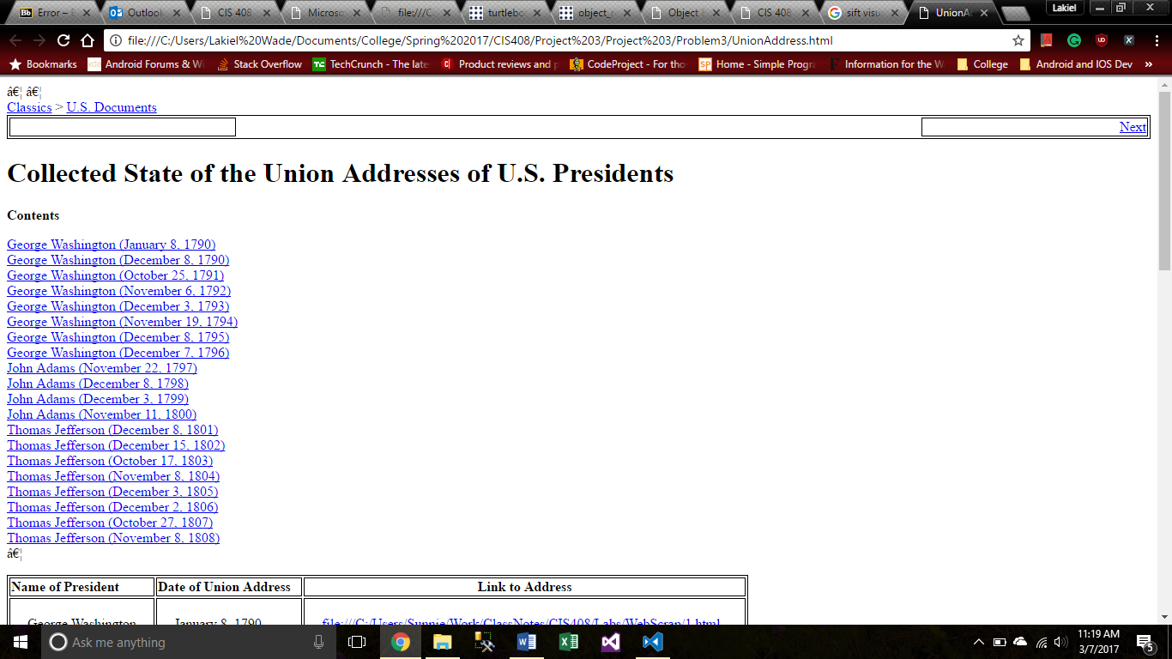

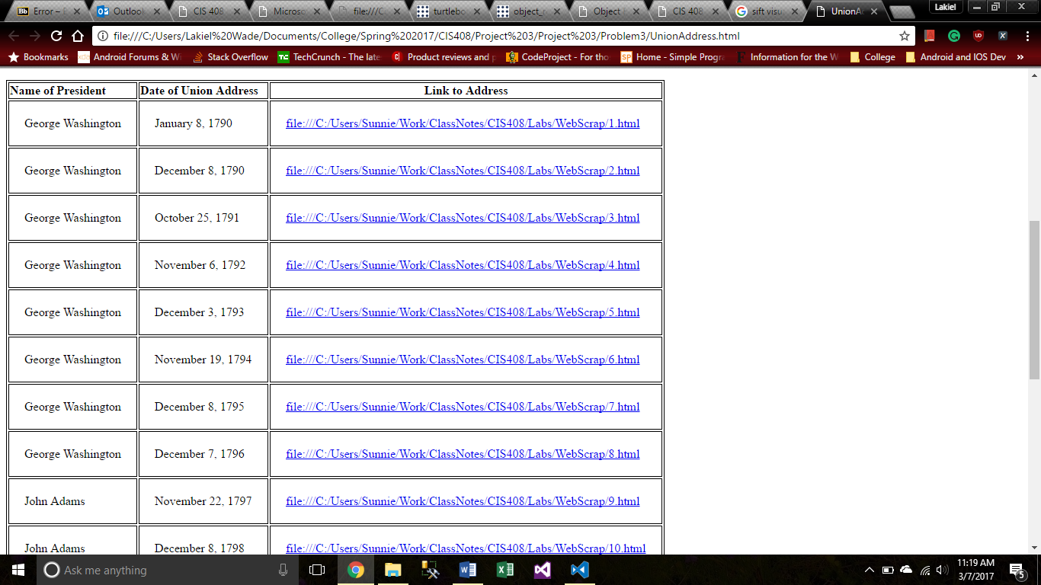

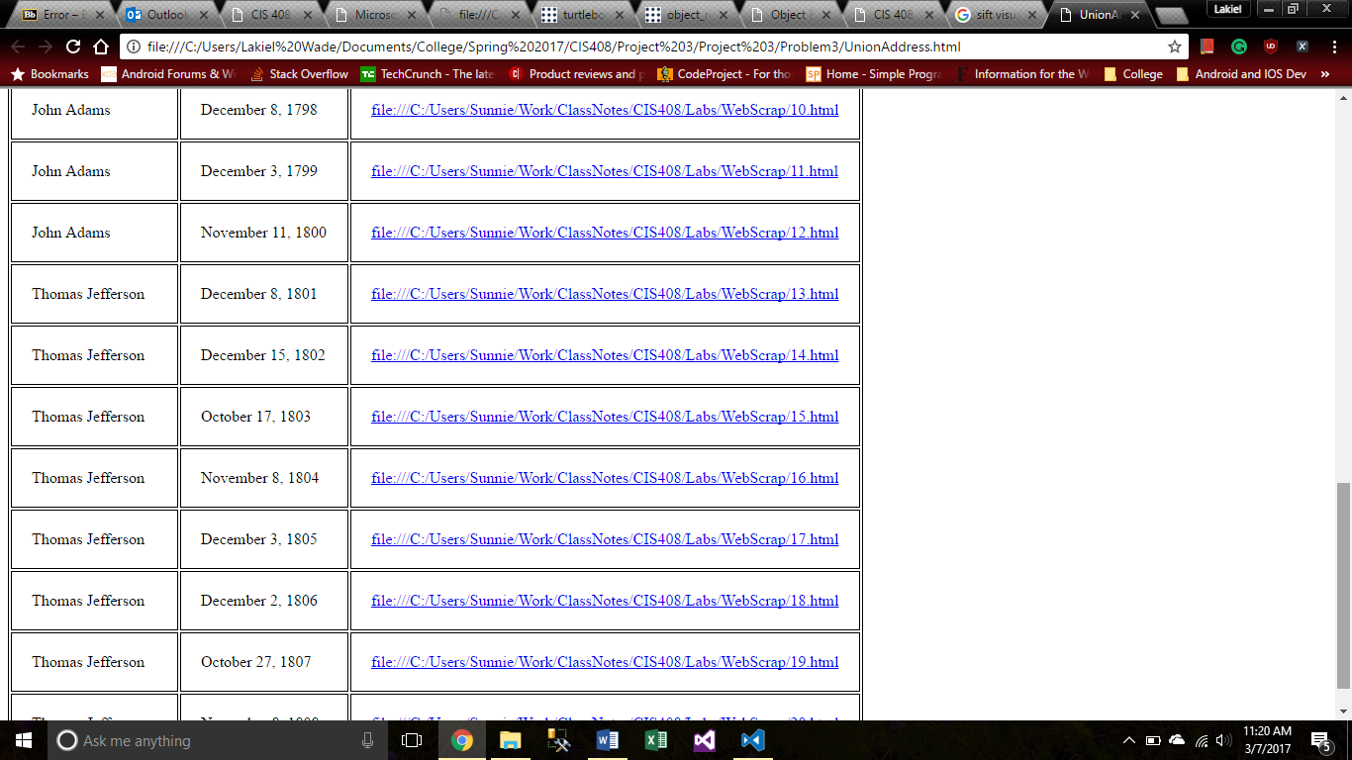

UnionAddress.html

<!DOCTYPE html>

<html>

<head>

    <meta http-equiv="Content-Type" content="text/html; charset=windows-1252">

    <link rel="stylesheet" type="text/css" href="UnionTable.css" />

    <style>

        table,

        td {

            border: 1px solid black;

        }

    </style>

</head>

<body>

    <script src="UnionTable.js"></script>… …

    <div style="position:relative">

        <div class="context"><a href="file:///C:/t/">Classics</a> &gt; <a href="file:///C:/t/us-history.html">U.S. Documents</a></div>

        <div class="navheader">

            <table width="100%" class="PageLinearNav" summary="Navigation header">

                <tbody>

                    <tr>

                        <td width="20%" align="left" class="PLN-prev">&nbsp;</td>

                        <th align="center">&nbsp;</th>

                        <td width="20%" align="right" class="PLN-next">&nbsp;<a accesskey="n" href="file:///C:/Users/Sunnie/Work/ClassNotes/CIS408/Labs/WebScrap/1.html">Next</a></td>

                    </tr>

                </tbody>

            </table>

        </div>

        <div class="book" lang="en" xml:lang="en">

            <div class="titlepage">

                <div>

                    <div>

                        <h1 class="title">

                            <a id="idm6504896"></a>Collected State of the Union Addresses of U.S. Presidents</h1>

                    </div>

                </div>

            </div>

            <div class="toc">

                <p><b>Contents</b></p>

                <dl>

                    <dt><span xmlns="" class="article"><a href="file:///C:/Users/Sunnie/Work/ClassNotes/CIS408/Labs/WebScrap/1.html">George Washington (January 8, 1790)</a></span></dt>

                    <dt><span xmlns="" class="article"><a href="file:///C:/Users/Sunnie/Work/ClassNotes/CIS408/Labs/WebScrap/2.html">George Washington (December 8, 1790)</a></span></dt>

                    <dt><span xmlns="" class="article"><a href="file:///C:/Users/Sunnie/Work/ClassNotes/CIS408/Labs/WebScrap/3.html">George Washington (October 25, 1791)</a></span></dt>

                    <dt><span xmlns="" class="article"><a href="file:///C:/Users/Sunnie/Work/ClassNotes/CIS408/Labs/WebScrap/4.html">George Washington (November 6, 1792)</a></span></dt>

                    <dt><span xmlns="" class="article"><a href="file:///C:/Users/Sunnie/Work/ClassNotes/CIS408/Labs/WebScrap/5.html">George Washington (December 3, 1793)</a></span></dt>

                    <dt><span xmlns="" class="article"><a href="file:///C:/Users/Sunnie/Work/ClassNotes/CIS408/Labs/WebScrap/6.html">George Washington (November 19, 1794)</a></span></dt>

                    <dt><span xmlns="" class="article"><a href="file:///C:/Users/Sunnie/Work/ClassNotes/CIS408/Labs/WebScrap/7.html">George Washington (December 8, 1795)</a></span></dt>

                    <dt><span xmlns="" class="article"><a href="file:///C:/Users/Sunnie/Work/ClassNotes/CIS408/Labs/WebScrap/8.html">George Washington (December 7, 1796)</a></span></dt>

                    <dt><span xmlns="" class="article"><a href="file:///C:/Users/Sunnie/Work/ClassNotes/CIS408/Labs/WebScrap/9.html">John Adams (November 22, 1797)</a></span></dt>

                    <dt><span xmlns="" class="article"><a href="file:///C:/Users/Sunnie/Work/ClassNotes/CIS408/Labs/WebScrap/10.html">John Adams (December 8, 1798)</a></span></dt>

                    <dt><span xmlns="" class="article"><a href="file:///C:/Users/Sunnie/Work/ClassNotes/CIS408/Labs/WebScrap/11.html">John Adams (December 3, 1799)</a></span></dt>

                    <dt><span xmlns="" class="article"><a href="file:///C:/Users/Sunnie/Work/ClassNotes/CIS408/Labs/WebScrap/12.html">John Adams (November 11, 1800)</a></span></dt>

                    <dt><span xmlns="" class="article"><a href="file:///C:/Users/Sunnie/Work/ClassNotes/CIS408/Labs/WebScrap/13.html">Thomas Jefferson (December 8, 1801)</a></span></dt>

                    <dt><span xmlns="" class="article"><a href="file:///C:/Users/Sunnie/Work/ClassNotes/CIS408/Labs/WebScrap/14.html">Thomas Jefferson (December 15, 1802)</a></span></dt>

                    <dt><span xmlns="" class="article"><a href="file:///C:/Users/Sunnie/Work/ClassNotes/CIS408/Labs/WebScrap/15.html">Thomas Jefferson (October 17, 1803)</a></span></dt>

                    <dt><span xmlns="" class="article"><a href="file:///C:/Users/Sunnie/Work/ClassNotes/CIS408/Labs/WebScrap/16.html">Thomas Jefferson (November 8, 1804)</a></span></dt>

                    <dt><span xmlns="" class="article"><a href="file:///C:/Users/Sunnie/Work/ClassNotes/CIS408/Labs/WebScrap/17.html">Thomas Jefferson (December 3, 1805)</a></span></dt>

                    <dt><span xmlns="" class="article"><a href="file:///C:/Users/Sunnie/Work/ClassNotes/CIS408/Labs/WebScrap/18.html">Thomas Jefferson (December 2, 1806)</a></span></dt>

                    <dt><span xmlns="" class="article"><a href="file:///C:/Users/Sunnie/Work/ClassNotes/CIS408/Labs/WebScrap/19.html">Thomas Jefferson (October 27, 1807)</a></span></dt>

                    <dt><span xmlns="" class="article"><a href="file:///C:/Users/Sunnie/Work/ClassNotes/CIS408/Labs/WebScrap/20.html">Thomas Jefferson (November 8, 1808)</a></span></dt>

                    …

                </dl>

            </div>

        </div>

    </div>

    <table cell-spacing=0 id="UnionTable">

        <tr class="header">

            <td>Name of President</td>

            <td>Date of Union Address</td>

            <td id="LinkHeader">Link to Address</td>

        </tr>

    </table>

</body>

<script type="text/javascript">

    UnionTable.GenerateTable();

</script>

</html>

UnionTable.js

class UnionTable {

    static GenerateTable() {

        var docContents = document.getElementsByClassName("toc");

        docContents = docContents[0].childNodes[3].children

        var name = "",

            date = "",

            address = "";

        for (var x = 0; x < docContents.length; x++) {

            var text = docContents[x].innerText;

            var html = docContents[x].innerHTML;

            name = text.substring(0, text.indexOf('(') - 1);

            date = text.substring(text.indexOf('(') + 1, text.indexOf(')'));

            address = html.substring(html.indexOf("href=") + 6, html.indexOf(".html") + 5);

            UnionTable.appenedTable(name, date, address);

            console.log("fdg");

        }

    }

    static appenedTable(name, date, address) {

        var table = document.getElementById("UnionTable");

        var rowCount = table.rows.length;

        var row = table.insertRow(rowCount);

        row.className = "row"

        var cell1 = row.insertCell(0);

        cell1.className = "cell"

        var cell2 = row.insertCell(1);

        cell2.className = "cell"

        var cell3 = row.insertCell(2);

        cell3.className = "cell"

        cell1.innerHTML = name;

        cell2.innerHTML = date;

        var link = document.createElement("a");

        link.setAttribute('href',address)

        link.innerHTML = address;

        cell3.appendChild(link);

    }

}